CUSTOMER RELATIONSHIP MANAGEMENT

INDEX PAGE

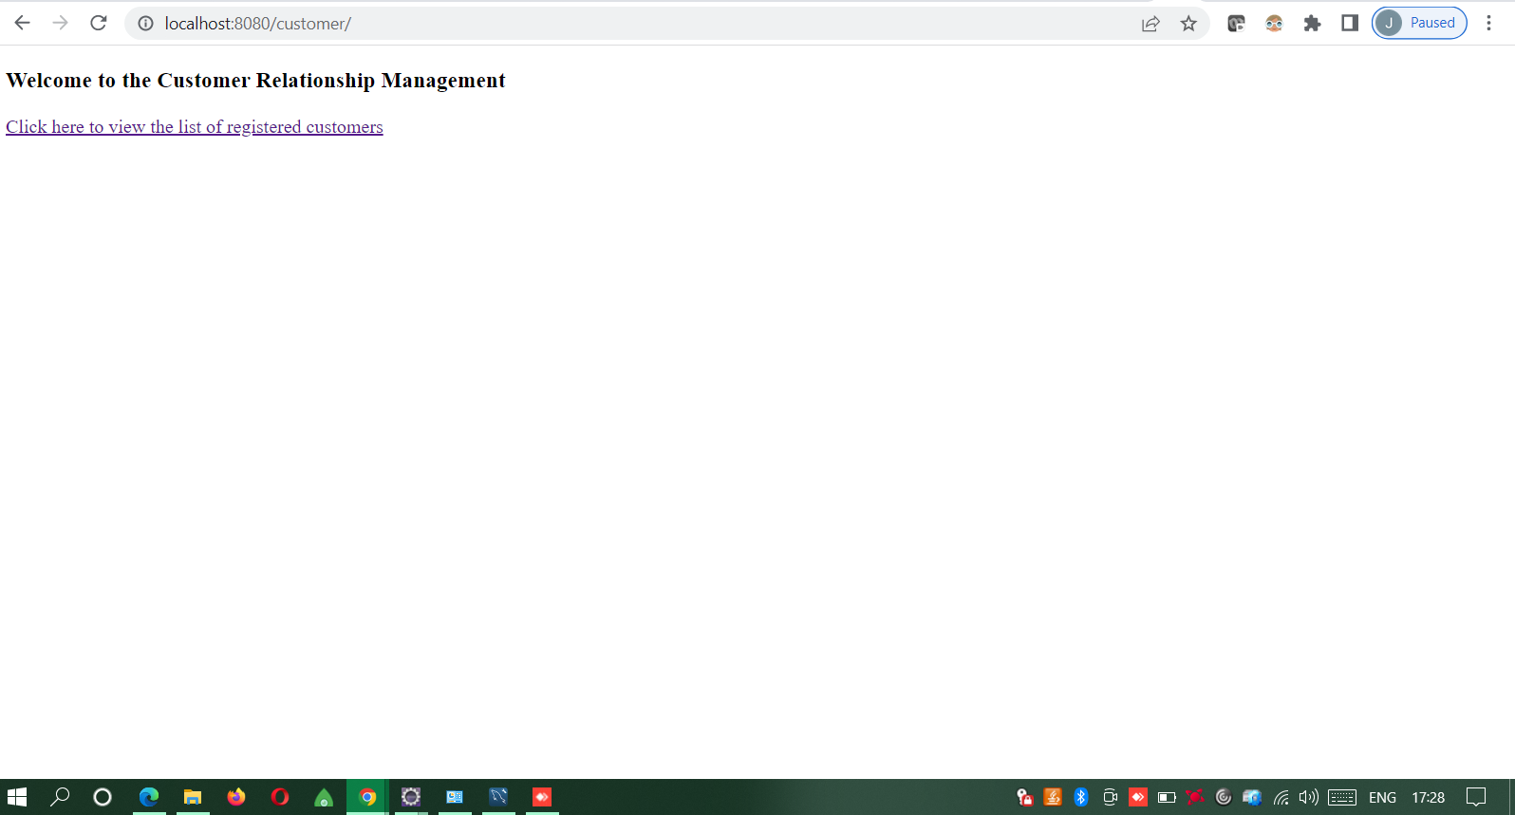

CUSTOMER LIST PAGE

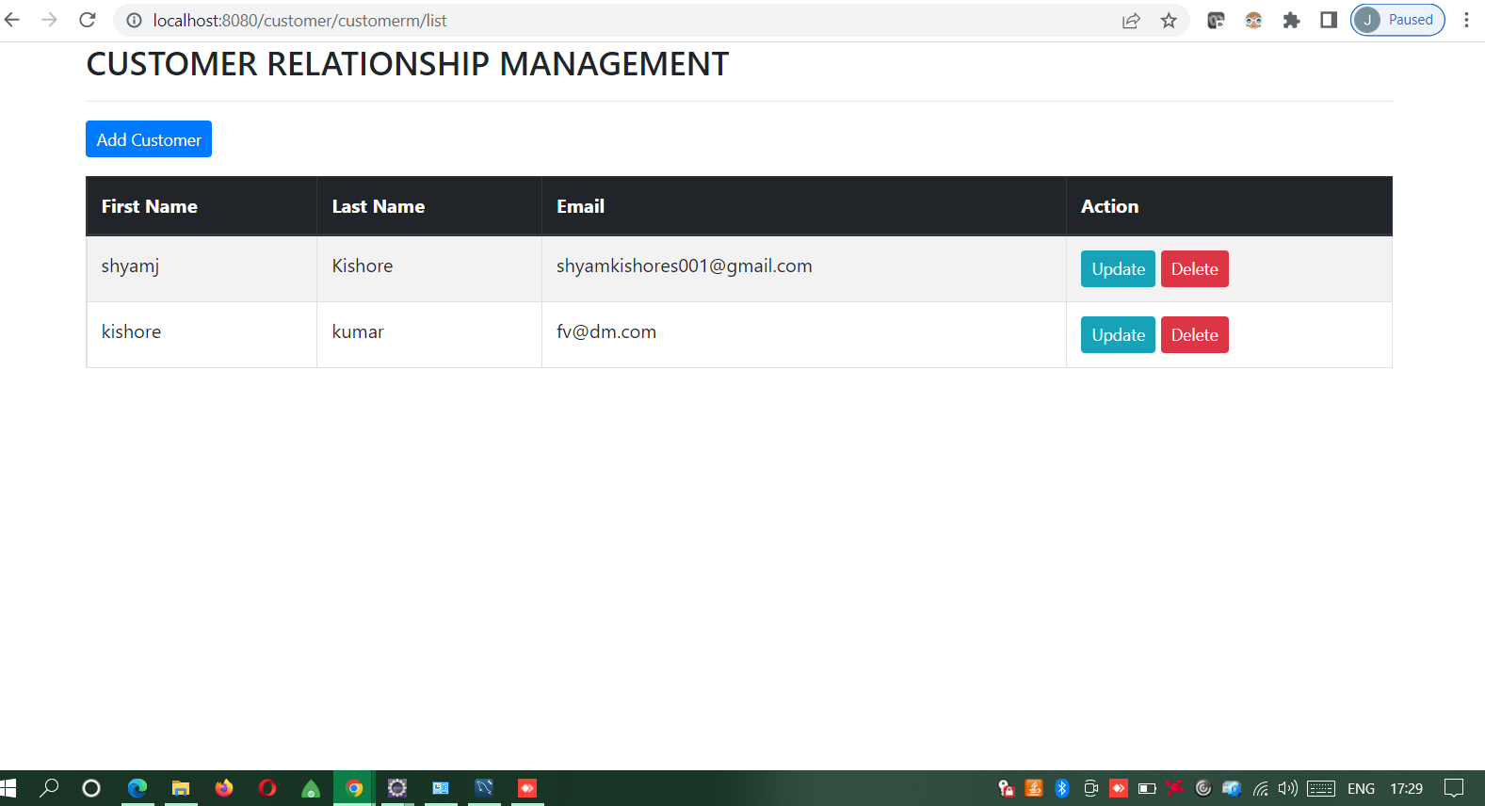

ADD NEW CUSTOMER

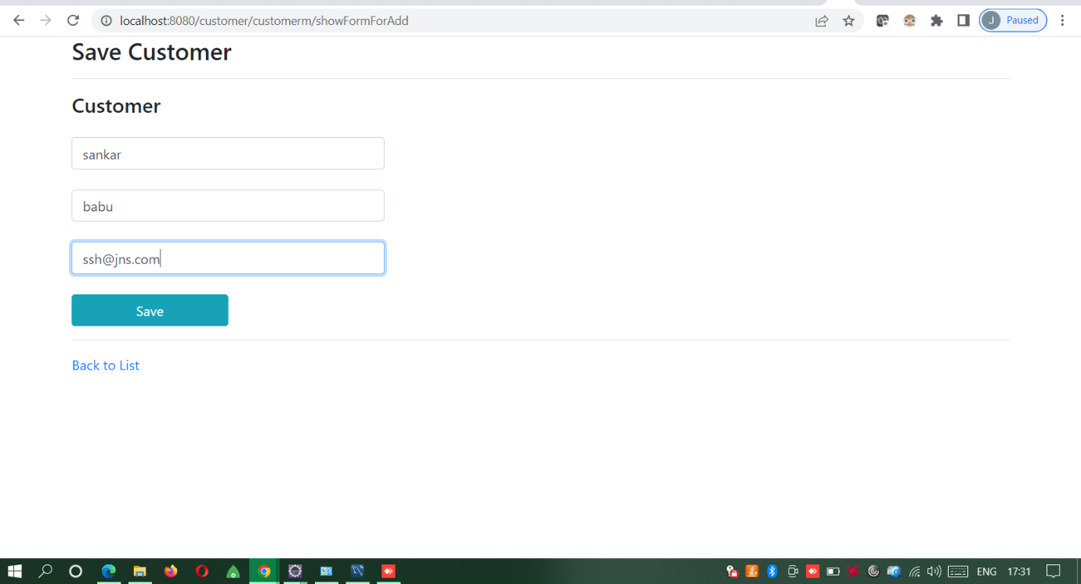

NEW CUSTOMER ADDED TO THE LIST

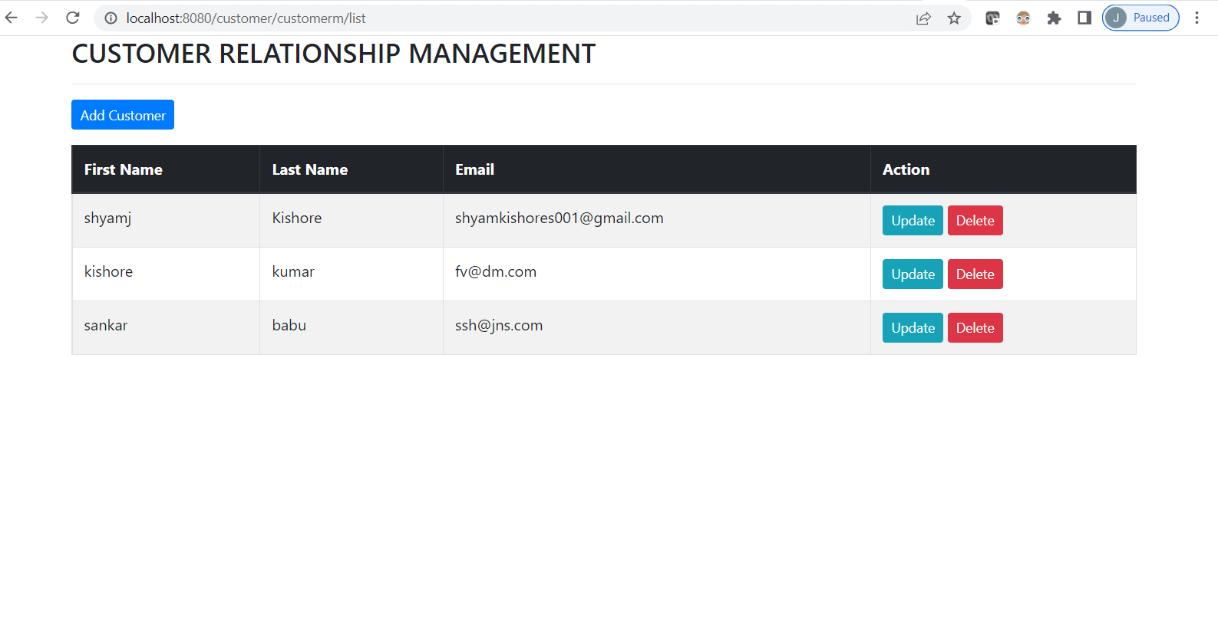

UPDATE sankar babu to sankarganesh babu

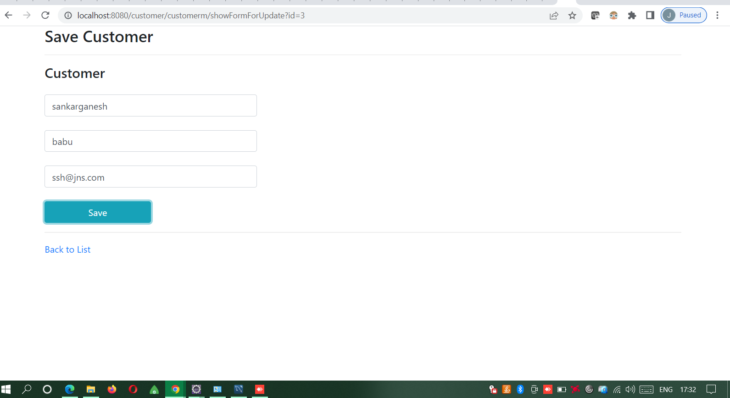

UPDATED NAME REFLECTING IN LIST

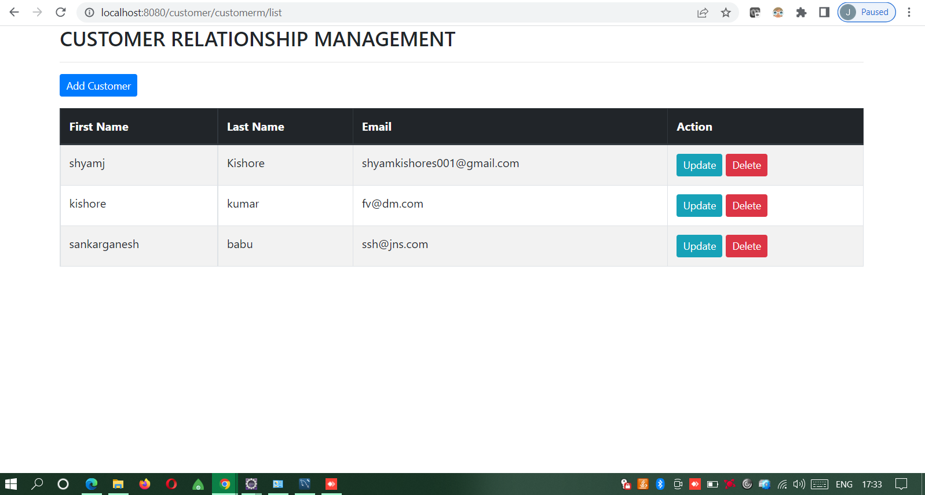

DELETING sankarganesh babu ---POP UP BEFORE DELETNG

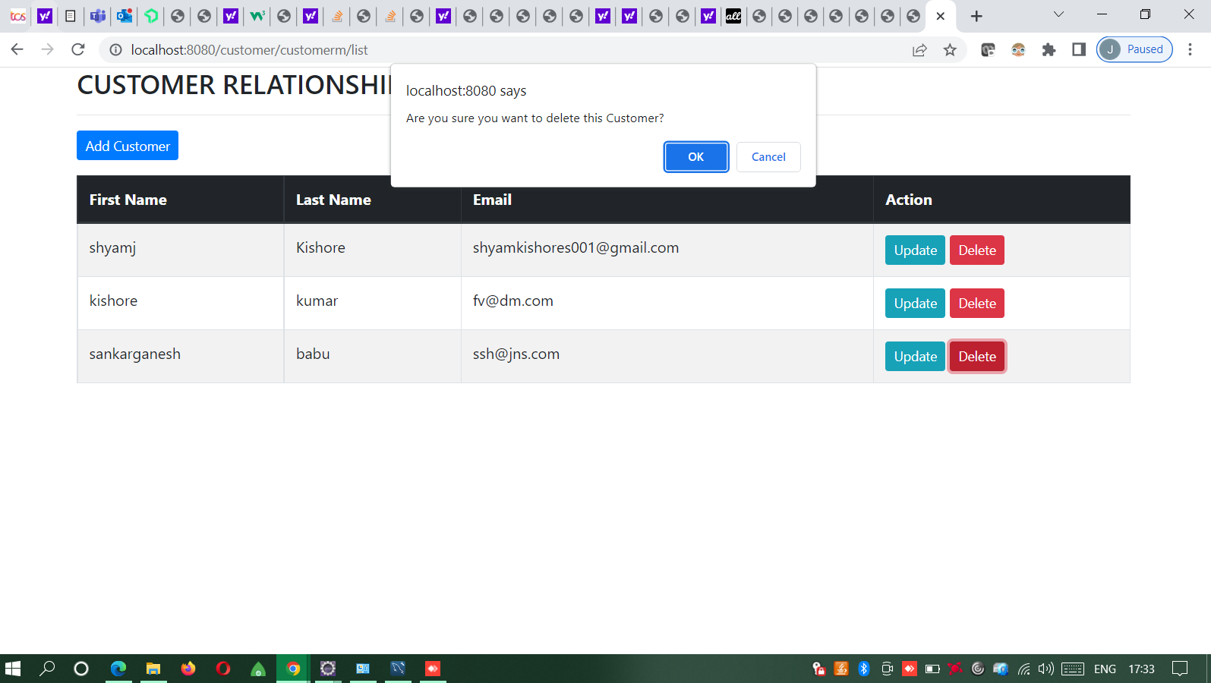

LIST AFTER DELETING

